Section 1 _ w19_shiner1

1.

SELECT *

From EMP

Where deptno = 10

or comm is not null

or (deptno = 20 and sal <= 2000);

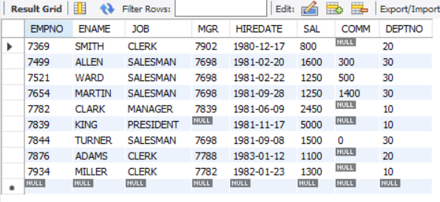

2.

SELECT Ename, Job

from EMP

where deptno = 10;

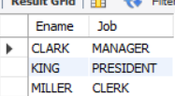

3.

SELECT Concat(Ename, " WORKS AS A ", Job) as Works_As  
from EMP  
where deptno = 10;

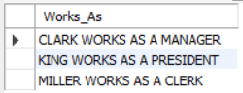

4.

Select ename, sal,

Case When sal <= 2000 Then "UNDERPAID"

when sal >= 4000 THEN "OVERPAID"

else "OK" end as Status

from EMP;

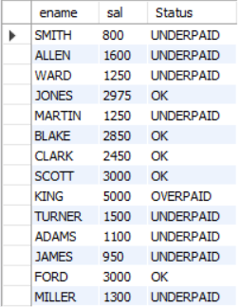

5.

select ename, job

from EMP

where deptno in (10, 20)

and (ename like "%I%" or job like "%ER");

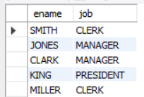

6.

select ename,

job from EMP

order by right(job, 3) asc

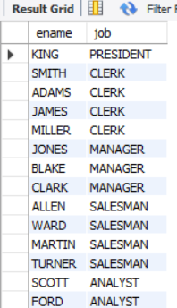

USED w19shiner_3 for section 2 questions, start sec 2 here

7.

select title, category

from BOOKS

where category != "FITNESS"

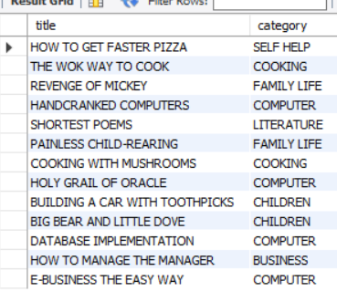

8.

select customer_num, lastname, state

from CUSTOMERS

where state = "GA" or state = "NJ"

order by lastname asc

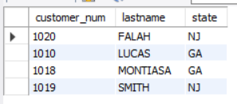

9.

select lname, fname

from AUTHOR

where lname like "%IN%"

order by lname, fname

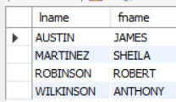

10.

select isbn, title  
from BOOKS  
where title like "_A%"  
and title like "___N%"  
order by title desc

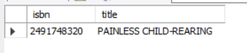

Section 2 ends here, below is section 4 db w19shiner_5

11.

select concat(last_name, ", ", first_name) as full_name

from customers

where last_name >= 'M'

order by last_name asc

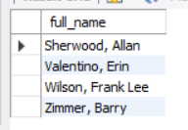

12.

select product_name, list_price, discount_percent,

round((list_price * discount_percent/100), 2) as discount_amount,

round((list_price - (list_price * discount_percent/100)), 2) as discount_price

from products

order by discount_price desc

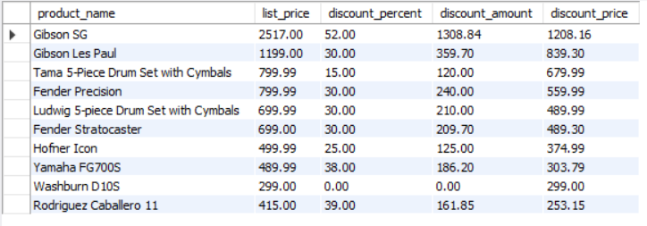

13.

select item_id, item_price, discount_amount, quantity,

(item_price * quantity) as price_total,

(discount_amount * quantity) as discount_total,

((item_price - discount_amount) * quantity) as item_total

from order_items

where ((item_price - discount_amount) * quantity) > 500

order by ((item_price - discount_amount) * quantity) desc

